**Selenium WebDriver: Access Form, CheckBox, RadioButton & TextBox**

In this tutorial, we will learn how to access forms and its  elements using Webdriver

**Accessing Form Elements**

**Input Box**

Input boxes refer to either of these two types:

1. **Text Fields**- text boxes that accept typed values and show them as they are.
2. **Password Fields**- text boxes that accept typed values but mask them as a series of special characters (commonly dots and asterisks) to avoid sensitive values to be displayed.

[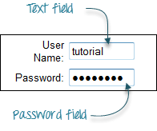](http://cdn.guru99.com/images/image002(1).png)

**Entering Values in Input Boxes**

The **sendKeys()** method is used to enter values into input boxes.

[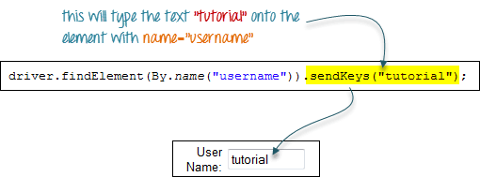](http://cdn.guru99.com/images/image003(2).png)

**Deleting Values in Input Boxes**

The **clear()** method is used to delete the text in an input box. **This method does not need any parameter**. The code snippet below will clear out the text "tutorial" in the User Name text box.

[Selenium WebDriver: Access Form, CheckBox, RadioButton & TextBox](http://cdn.guru99.com/images/image004(3).png)

**Radio Button**

Toggling a radio button on is done using the **click()**method.

[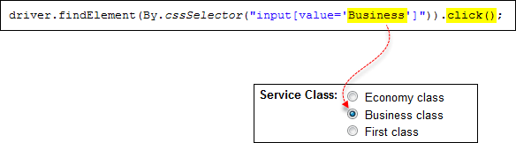](http://cdn.guru99.com/images/image005(3).png)

**Check Box**

Toggling a check box on/off is also done using the **click()** method.

The code below will click on Facebook's "Keep me logged in" check box twice and then output the result as TRUE when it is toggled on, and FALSE if it is toggled off.

[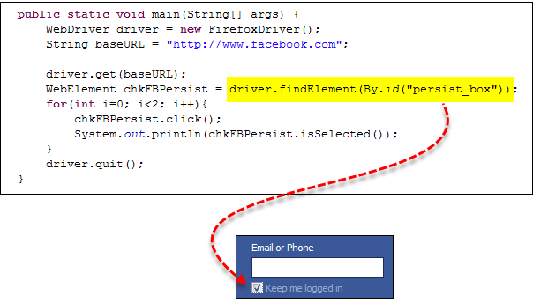](http://cdn.guru99.com/images/image006(3).png)

[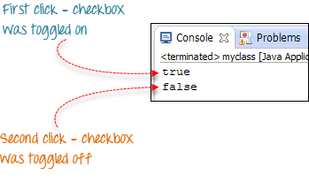](http://cdn.guru99.com/images/image007(3).png)

**Links**

Links also are accessed by using the **click()** method.

Consider the below link found in Mercury Tours' homepage.

[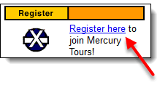](http://cdn.guru99.com/images/image008(4).png)

You can access this link using linkText() or partialLinkText() together with click(). Either of the two lines below will be able to access the "Register here" link shown above.

[Selenium WebDriver: Access Form, CheckBox, RadioButton & TextBox](http://cdn.guru99.com/images/image009(4).png)

[Selenium WebDriver: Access Form, CheckBox, RadioButton & TextBox](http://cdn.guru99.com/images/image010(3).png)

**Submitting a Form**

The **submit()**method is used to submit a form. This is an alternative to clicking the form's submit button.

 You can use submit() on any element within the form, not just on the submit button itself.

[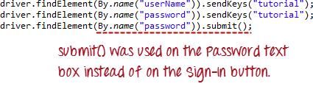](http://cdn.guru99.com/images/image023(1).png)

**When submit() is used, WebDriver will look up the DOM to know which form the element belongs to, and then trigger its submit function.**

**Here is the complete code**

package newPackage;

import org.openqa.selenium.By;

import org.openqa.selenium.WebDriver;

import org.openqa.selenium.WebElement;

import org.openqa.selenium.firefox.FirefoxDriver;

import org.openqa.selenium.support.ui.ExpectedConditions;

import org.openqa.selenium.support.ui.WebDriverWait;

public class Test {

public static void main(String[] args) {

// declaration and instantiation of objects/variables

WebDriver driver ;

System.setProperty("webdriver.firefox.marionette","C:\\geckodriver.exe");

driver = new FirefoxDriver();

//Create explicit wait.

WebDriverWait myWait = new WebDriverWait(driver, 10);

String baseUrl = "http://newtours.demoaut.com/";

driver.get(baseUrl);

//wait until text box load.

myWait.until(ExpectedConditions.visibilityOfElementLocated(By.name("userName")));

// Enter value into textbox

driver.findElement(By.name("userName")).sendKeys ("tutorial");

// Delete value from textbox

driver.findElement(By.name("userName")).clear();

// Access Links

driver.findElement(By.linkText("Register here")).click();

driver.findElement(By.partialLinkText("SIGN-ON")).click();

// Enter value into textbox and SUBMIT

driver.findElement(By.name("userName")).sendKeys ("tutorial");

driver.findElement(By.name("password")).sendKeys ("tutorial");

driver.findElement(By.name("password")).submit();

// Select Radio Button

driver.findElement(By.cssSelector("input[value=Business]")).click();

//Select CheckBox

String baseURL = "http://demo.guru99.com/sele...";

driver.get(baseURL);

//Create an Explicit wait.

WebDriverWait myWait2 = new WebDriverWait(driver, 10);

myWait2.until(ExpectedConditions.visibilityOfElementLocated(By.id("persist_box")));

WebElement chkFBPersist = driver.findElement(By.id("persist_box"));

for (int i=0; i<2; i++) {

chkFBPersist.click ();

System.out.println(chkFBPersist.isSelected());

}

driver.quit();

System.exit(0);

}

}